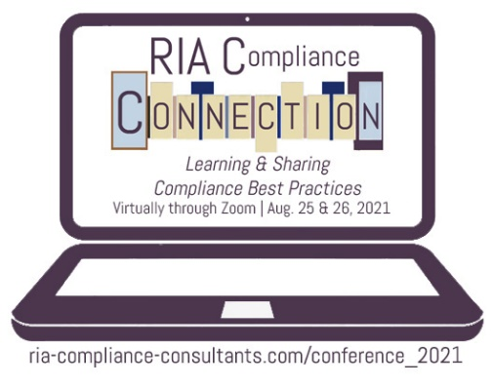
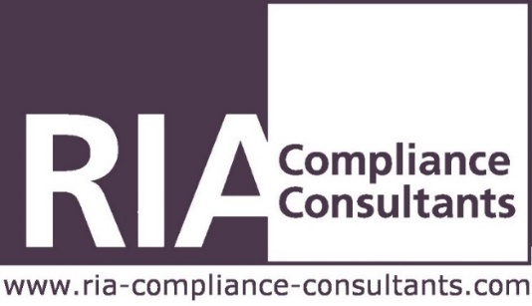

Agenda
The following is a tentative agenda for our RIA Compliance Connection 2021 Conference. The agenda is subject to change and is meant to serve only as a general overview.
Wednesday, August 25, 2021

Day One Sessions - All times central
9:40 to 10:00 AM – Registration
10:00 to 10:20 AM– Opening Remarks by Bryan Hill, President of RIA Compliance Consultants
10:20 to 11:20 AM – First Consultant Led Breakout Group Session
11:30 AM to 12:30 PM – Second Consultant Led Breakout Group Session
12:30 to 12:45 PM – Summary and general discussion of the day’s Breakout Sessions
Thursday, August 26, 2021

Day Two Sessions – All Times Central
10:00 to 10:20 AM– Registration
10:20 to 10:30 AM – Opening Remarks by Bryan Hill, President of RIA Compliance Consultants
10:30 to 11:20 AM – Session 1: Conflicts of Interest
11:25 AM to 12:15 PM – Session: 2 SEC’s New marketing Rule
12:15 to 12:30 PM – Break
12:30 to 1:20 PM – Session 3: Cybersecurity
1:25 to 2:15 PM– Session 4: RIA Standard of Conduct/Care
2:20 to 3:00 PM – Session 5: Any Questions? – Q&A Panel with our Senior Compliance Consultants
RIA Compliance Consultants would like to recognize and thank the following Strategic Alliance Members and Conference Sponsors

