Description of Scholarships to Attend 2021 RIA Compliance Connection
Presented by RIA Compliance Consultants, Inc.

RIA Compliance Consultants will be awarding up to three scholarships to undergraduate or graduate students, who have demonstrated interest in compliance, personal finance or investment management, for purposes of attending the 2021 RIA Compliance Connection, an investment adviser compliance conference sponsored by RIA Compliance Consultants, Inc. RIA Compliance Connection will be held on Wednesday, August 25 and Thursday, August 26, 2021 virtually through Zoom.

During the 2021 RIA Compliance Connection, the scholarship recipients will have the opportunity to learn about some of the latest regulatory trends facing investment adviser firms and the opportunity to network with investment adviser leaders and chief compliance officers throughout the United States. The scholarship will cover the cost of the registration.

In order to apply for the scholarship, an individual must be enrolled currently as an undergraduate or graduate student at a higher education institution in 2021 or a recent graduate (from May – August 2021) from a higher education institution. An individual desiring to apply for the scholarship will need to complete and submit our application by July 15, 2021. There are a limited number of scholarships, and the awarding of the scholarship is a competitive process which will be made solely at the discretion of RIA Compliance Consultants.

RIA Compliance Consultants will be sharing the names and a brief background of each scholarship recipient to the other attendees to help facilitate networking opportunities. Each recipient will be introduced and recognized at the conference.

If you have any questions, please contact our committee at scholarship@ria-compliance-consultants.com.

Scholarship Application to Attend 2021 RIA Compliance Connection
Presented by RIA Compliance Consultants, Inc.

Student Name:

Student Email Address:

Student Phone Number:

Home Address:

Name of Academic Institution:

Course of Study:

GPA out of 4.00

Graduation Date (expected):

Tentative Plans Upon Graduation:

Explain Your Interest in Compliance, Personal Finance, Investments and/or Portfolio Management:

Tell Us About Yourself Include Any Activities and Internships:

Reference 1
Name:

Relationship:

Organization:

Email Address:

Phone Number:

Reference 2
Name:

Relationship:

Organization:

Email Address:

Phone Number:

If I’m selected as a scholarship recipient, I hereby authorize RIA Compliance Consultants, Inc. to prepare a newsletter articles and blog posts which identify me as a scholarship recipient and discuss my interest in compliance, personal finance, investments and/or portfolio management and take my photo for such newsletter articles and blog posts.

Please Include a Copy of Your Resume to Complete this Application

Email Completed Application and Your Resume to
scholarship@ria-compliance-consultants.com

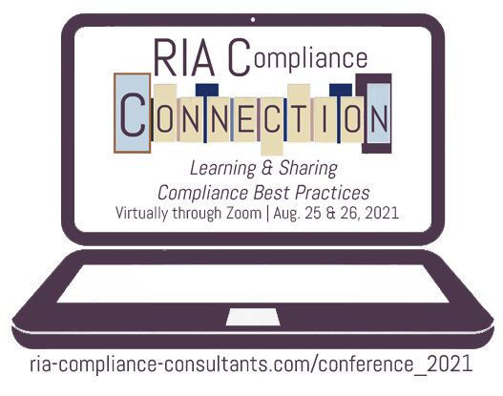
Presented by RIA Compliance Consultants, Inc.

Join RIA Compliance Consultants for the 2021 RIA Compliance Connection. We will lead discussions on how investment adviser firms can successfully navigate the regulatory maze and adopt appropriate procedures for their compliance programs. Learn more at ria-compliance-consultants.com/conference.

Conference attendees have included:
- Chief Compliance Officers / Investment Advisers / General Counsels
- Managing Directors /Operations Officers
- State registered RIAs/ SEC Registered RIAs

RIA Compliance Consultants will be awarding up to three scholarships to undergraduate or graduate students, who have demonstrated interest in compliance, personal finance or investment management, for purposes of attending the 2021 RIA Compliance Connection, an investment adviser compliance conference sponsored by RIA Compliance Consultants, Inc. RIA Compliance Connection will be held on Wednesday, August 25 and Thursday, August 26, 2021 at the Scott Conference Center on the Aksarben campus of University of Nebraska-Omaha.

Visit ria-compliance-consultants.com/conference_2021/
to learn more and to apply.
Scholarship Opportunities to Attend:

