Anyone who has ever worked in compliance understands that compliance professionals play a critical role that is often overlooked. In an effort to recognize the hard work of so many dedicated compliance professionals RIA Compliance Consultants (RCC) is proud to offer our Compliance Person of the Year Award. This honor will serve to recognize the best of the best within the ranks of investment adviser compliance.

In choosing the recipient, several things will be considered, including years of experience, leadership, character, and a great compliance program. The winner of the Compliance Professional of the Year Award will be announced during 2021 RIA Compliance Connection, our annual investment adviser compliance conference hosted on August 25 and 26, 2021 through Zoom.

The winner of the award will receive a complimentary seat to 2021 RIA Compliance Connection. RIA Compliance Consultants will also donate $500 to a charity of the Compliance Professional of the Year’s choosing.

RIA Compliance Consultants is now accepting applications for the Compliance Professional of the Year. You can nominate yourself or someone you think exemplifies a true compliance professional. All applications must be submitted no later than July 15, 2021.
Application - Compliance Professional of the Year
Presented by RIA Compliance Consultants, Inc.

Nominee’s Name:

Nominee’s RIA:

Nominee’s Email Address:

Nominee’s Phone Number:

How many years has the nominee worked in Compliance?

Please provide a history of the nominee’s career in compliance including positions held, key compliance duties, and licenses or designations if applicable:

Please identify compliance concerns the nominee has faced and how she or he has handled those concerns:

Tell us about the nominee and why she or he should be recognized as the Compliance Professional of the Year:

Reference 1
Name:

Relationship:

Organization:

Email Address:

Phone Number:

Reference 2 (Optional)
Name:

Relationship:

Organization:

Email Address:

Phone Number:

Email Completed Application and Your Resume to
bizdevteam@ria-compliance-consultants.com no later than July 15, 2021

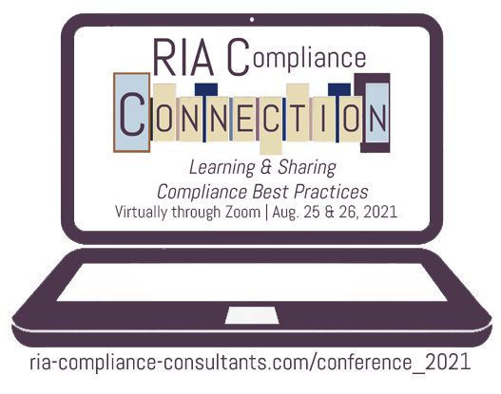
Presented by RIA Compliance Consultants, Inc.

Join RIA Compliance Consultants for the 2021 RIA Compliance Connection. We will lead discussions on how investment adviser firms can successfully navigate the regulatory maze and adopt appropriate procedures for their compliance programs. Learn more at ria-compliance-consultants.com/conference.

Conference attendees have included:
- Chief Compliance Officers / Investment Advisers / General Counsels
- Managing Directors /Operations Officers
- State registered RIAs/ SEC Registered RIAs

RIA Compliance Consultants will be awarding up to three scholarships to undergraduate or graduate students, who have demonstrated interest in compliance, personal finance or investment management, for purposes of attending the 2020 RIA Compliance Connection, an investment adviser compliance conference sponsored by RIA Compliance Consultants, Inc. RIA Compliance Connection will be held on Wednesday, August 25 and Thursday, August 26, 2021 virtually through Zoom.

Visit ria-compliance-consultants.com/conference_2021/
to learn more and to apply.
Scholarship Opportunities to Attend:

