Anyone who has ever worked in compliance understands that compliance professionals play a critical role that is often overlooked. In an effort to recognize the hard work of so many dedicated compliance professionals RIA Compliance Consultants (RCC) is proud to offer our Compliance Person of the Year Award. This honor will serve to recognize the best of the best within the ranks of investment adviser compliance.

In choosing the recipient, several things will be considered, including years of experience, leadership, character, and a great compliance program. The winner of the Compliance Professional of the Year Award will be announced during RIA Compliance Connection 2020, our annual investment adviser compliance conference hosted on August 26 and 27, 2020 through Zoom.com.

The winner of the award will receive a complimentary seat to RIA Compliance Connection 2020. RIA Compliance Consultants will also donate $500 to a charity of the Compliance Professional of the Year’s choosing.

RIA Compliance Consultants is now accepting applications for the Compliance Professional of the Year. You can nominate yourself or someone you think exemplifies a true compliance professional. All applications must be submitted no later than July 15, 2020.
Application - Compliance Professional of the Year
Presented by RIA Compliance Consultants, Inc.

Nominee’s Name:

Nominee’s RIA:

Nominee’s Email Address:

Nominee’s Phone Number:

How many years has the nominee worked in Compliance?

Please provide a history of the nominee’s career in compliance including positions held, key compliance duties, and licenses or designations if applicable:

Please identify compliance concerns the nominee has faced and how she or he has handled those concerns:

Tell us about the nominee and why she or he should be recognized as the Compliance Professional of the Year:

Reference 1
Name:

Relationship:

Organization:

Email Address:

Phone Number:

Reference 2 (Optional)
Name:

Relationship:

Organization:

Email Address:

Phone Number:

Email Completed Application and Your Resume to
bizdevteam@ria-compliance-consultants.com no later than July 15, 2020

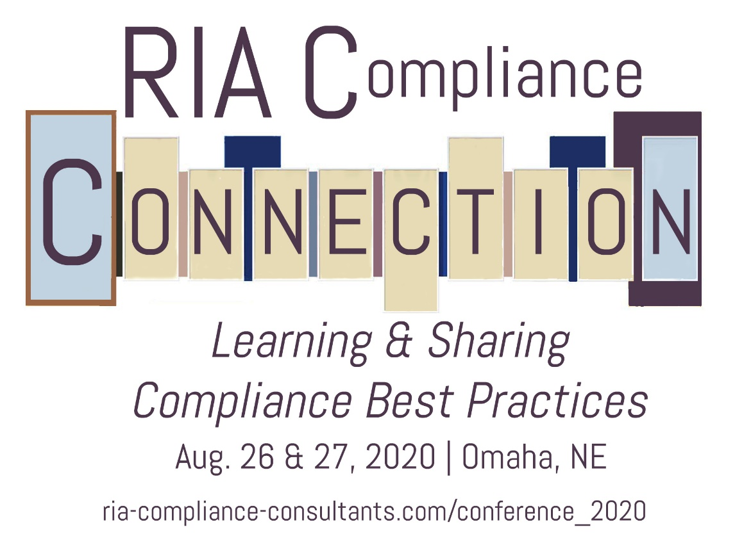
Presented by RIA Compliance Consultants, Inc.
Scott Conference Center
6450 Pine St,
Omaha, NE 68106

Join RIA Compliance Consultants for the 2020 RIA Compliance Connection. We will lead discussions on how investment adviser firms can successfully navigate the regulatory maze and adopt appropriate procedures for their compliance programs. Learn more at ria-compliance-consultants.com/conference.

Conference attendees have included:
- Chief Compliance Officers / Investment Advisers / General Counsels
- Managing Directors /Operations Officers
- State registered RIAs/ SEC Registered RIAs

RIA Compliance Consultants will be awarding up to three scholarships to undergraduate or graduate students, who have demonstrated interest in compliance, personal finance or investment management, for purposes of attending the 2020 RIA Compliance Connection, an investment adviser compliance conference sponsored by RIA Compliance Consultants, Inc. RIA Compliance Connection will be held on Wednesday, August 26 and Thursday, August 27, 2020 at the Scott Conference Center on the Aksarben campus of University of Nebraska-Omaha.

Visit ria-compliance-consultants.com/conference_2020/
to learn more and to apply.
Scholarship Opportunities to Attend:

